Chapter 2: Exploratory Data Analysis (Analysis)

**Introduction**2

**Univariate Analysis**3

Histograms 4

Bar charts/Count Plots 4

**Exercise 2.01: EDA – Univariate Analysis**5

**Bivariate Analysis**9

Types: 9

Bivariate Analysis of two numerical variables 9

Scatter Plot: 9

Linear Correlation 9

Bivariate Analysis of two categorical variables 9

Stacked Column Chart 9

Combination Chart 9

Bivariate Analysis of a numerical variable and a categorical variable 10

Line chart with Error Bars 10

Combination Chart 10

Z-test and T-test 10

Bivariate Correlations 11

**Exercise 2.02: EDA – Bivariate Analysis**11

**Multivariate Analysis**13

Types 13

Cluster Analysis 13

Correspondence Analysis 13

Principal Component Analysis 13

Single Index: 14

Multiple Index 14

Aggregates 15

**Exercise 2.03: Multivariate analysis**15

**Automated EDA Tooling**19

**Exercise 2.04: Automated EDA Tooling**20

**Activity 2.01: Loading the “City Land Mass - Miami” Dataset and performing Univariate and Bivariate Analysis on it.**22

**Conclusion**23

# Introduction

In the previous chapter, we learned about the aspects related to Exploratory Data Analysis. We were analyzing the datasets by making some investigations that were focusing on the structure, quality, content, and quantity of that data. Now in this chapter, we will be focusing on the more advanced structure of EDA. We will be practicing the concepts through exercises.

Exploratory data analysis is a data exploration approach that encourages statisticians to explore their data and possibly formulate hypotheses that might cause new data collection and experiments. EDA is a robust and efficient approach for checking that your data contains all the required information for model fitting and hypothesis testing. It also provides you with an understanding of how to handle missing values and make transformations of variables as needed.

It provides a solid base to build a robust understanding of the data, and issues associated with either the info or process. EDA is an innovative way to solve business problems by researching, planning, and creating solutions.

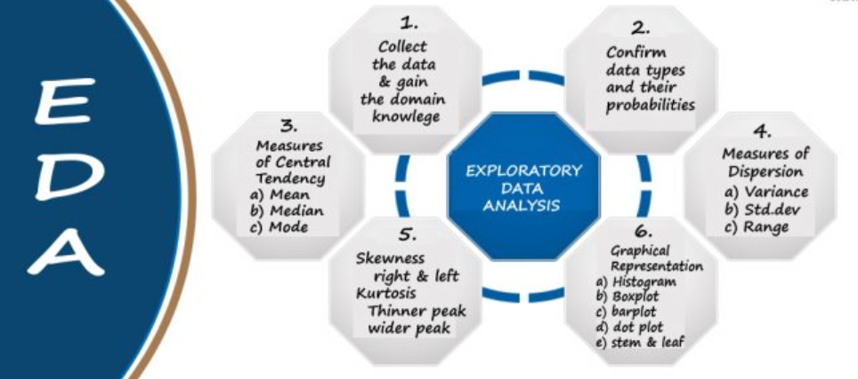

EDA is classified in two different ways where each method is either graphical or non-graphical. Moreover, each method is either **univariate, bivariate or multivariate.** These three methods will be covered in this chapter.

The data set that will be used in this chapter contains the following features:

* The name, state, district #, party, room #, phone #, and committee assignments of the US House of Representatives.

Also referred to as a congressman or congresswoman, each representative is elected to a two-year term serving the people of a specific congressional district. The number of voting representatives in the House is fixed by law at no more than 435, proportionally representing the population of the 50 states. Currently, there are five delegates representing the District of Columbia, the Virgin Islands, Guam, American Samoa, and the Commonwealth of the Northern Mariana Islands. A resident commissioner represents Puerto Rico. Learn more about representatives at The House Explained. You can learn more about this dataset from [here](https://data.world/adamhelsinger/directory-of-representatives).

# Univariate Analysis

Univariate analysis is a type of descriptive statistics that deal with one variable from a large amount of data. The objective is to derive the data; define and summarize it; and analyze its mean, variance, covariance, or correlation.

In a dataset, each variable is explored separately. It is possible for two kinds of variables:

* Categorical
* Numerical

The most common patterns to be identified when performing a univariate analysis are mean, mode and median. For example, if we were studying the air quality around a city that is experiencing heavy smog levels, we could identify the central tendency of a sample (n = 3) of people's perception of the air quality by looking at their answers to the question: "How clean or dirty did you feel while you were driving?

Similarly, Dispersion (range, variance), Quartiles (interquartile range), and Standard deviation can also be used for this analysis.

Before going into the details of the practice exercise, let us take a look at the data. This data has the following features:

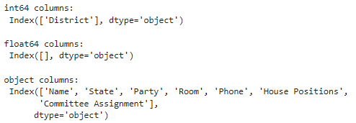

## Histograms

Histograms are similar to bar charts, displaying similar categorical variables against the category of data. They display the categories in the form of bins which indicate the number of data points within a range. They are used to represent a range of values and the frequency of those values within an interval.

In the upcoming exercises, we will be working on the histogram plots of continuous variables. Some outputs have been shown here:

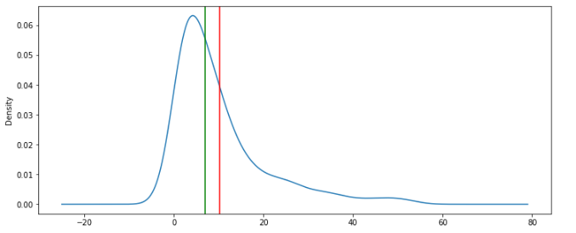

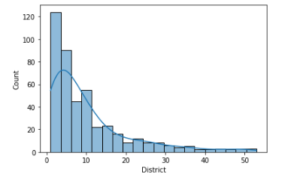

## Bar charts/Count Plots

The bar graph is very convenient when comparing categories of data or different groups of data. It lets users track the changes over time. It is best for visualizing discrete data. For the bar charts following syntax will be used:

sns.countplot(x="Party", data=df)

df['Party'].value_counts()

It has provided the result as shown in the figure. It is for the party variable:

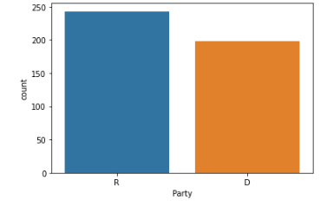

You can learn more about Univariate analysis from [here](https://youtu.be/WFMfNLUyG8E).

# Exercise 2.01: EDA – Univariate Analysis

In this exercise, a univariate analysis will be done by plotting histograms and bar charts. Load the dataset, import visualization libraries, and perform the analysis upon one variable out of all the variables of the given dataset.

First, perform the steps mentioned below to cover the major aspects of exploratory data analysis techniques:

1. Firstly, open the collab notebook and load the dataset from GitHub as shown below:



Output will be as follows:

1. Import the visualization libraries along with the other required ones.
2. Clean the dataset if required and handle with the data.
3. Get the total number of null values as shown below:

Output will be as follows:

1. Rename the columns as shown below:

Output will be as follows:

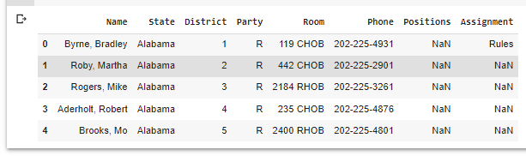

1. Perform univariate analysis of continuous variables as shown below:

Output will be as follows:

1. Make a list of numeric features from data as shown below:

1. Make a list of categorical features from data as shown below:

1. Remove the .columns and save it as a data frame as shown below:

Output will be as follows:

1. Plot histograms as shown below:

1. Show the counts of observations in each categorical bin using bars as shown below:

# Bivariate Analysis

Bi means two and variate means variable, so here there are two variables. The analysis is related to the cause and the relationship between the two variables.

## Types:

## Bivariate Analysis of two numerical variables

This type of bivariate analysis includes both dependent and independent variables with their numerical values. Some of its visual representation tools are mentioned below. These tools are visualized in the upcoming exercise.

### Scatter Plot:

It is drawn before working out a linear correlation or fitting a regression line. It is a useful representation of the relationship between two numerical variables.

### Linear Correlation

It quantifies the strength of a linear relationship between the two numerical variables. Without any correlation between the two variables, there is no tendency for the increase or decrease in the values of one variable with the increase or decrease in the values of another variable.

### Bivariate Analysis of two categorical variables

This type of bivariate analysis includes both dependent and independent variables with their categorical values.

### Stacked Column Chart

It is a visualization graph to see the relationship between two categorical variables. It makes a comparison between the percentage that each category from one variable contributes to overall such categories of the second variable.

### Combination Chart

It is also a visualization tool that utilizes two or more chart types to emphasize that charts contain different types of information. This type of chart is the best visualization method to demonstrate the predictability power of a predictor on the X-axis against a target on the Y-axis.

### Bivariate Analysis of a numerical variable and a categorical variable

This type of bivariate analysis includes one variable as categorical and the other variable as numerical.

### Line chart with Error Bars

It displays the information as a series of data points connected by straight-line segments. Each data point is the average of the numerical data for the relevant category of the categorical variable with an error bar showing standard error.

### Combination Chart

A combination chart can be used here too. It is used to demonstrate the same relationship as mentioned earlier.

### Z-test and T-test

These tests assess whether the averages of the two groups are statistically different from each other. These tests are preferred when the averages of a numerical variable for two categories of a categorical variable are compared.

# x = <NUMERIC VARIABLE>, hue = <CATEGORICAL VARIABLE>

plt.figure(figsize=(12,8))

sns.kdeplot(data=df,x='District',hue='State',fill=True)

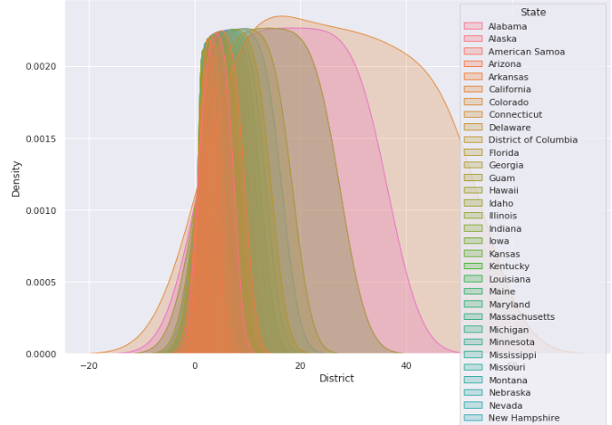

## Bivariate Correlations

Correlations measure how variables or rank orders are related. Before calculating a correlation coefficient, screen your data for outliers (which can cause misleading results) and evidence of a linear relationship. **Pearson'**s correlation coefficient tells us about the linear association. Two variables can be perfectly related, but if the relationship is not linear, Pearson's correlation coefficient is not an appropriate statistic for measuring their association. In the upcoming exercise, we have used “spearman’s method”.

You can learn more about bivariate analysis [Here.](https://www.youtube.com/watch?v=_m8v77qbkBA)

We will practice these concepts in the upcoming exercise.

# Exercise 2.02: EDA – Bivariate Analysis

In this exercise, the bivariate analysis will be done and the analysis will be done through the plots. Load the dataset, and import the required visualization libraries and tools to see the relationship between major categories of the two variables.

First, perform the steps mentioned in Exercise 2.01 to cover the major aspects of exploratory data analysis techniques:

Then perform bivariate analysis between two variables as shown below:

1. First, we will perform the GroupBy operation on the continuous variables. Groupby allows us to split our data into separate groups to perform computations for better analysis.
2. Get a global view of all continuous variables with respect to one categorical variable as shown below:

1. Then perform correlation.
2. Deal with the analysis of two variables and interpret the relationship between them as shown below:

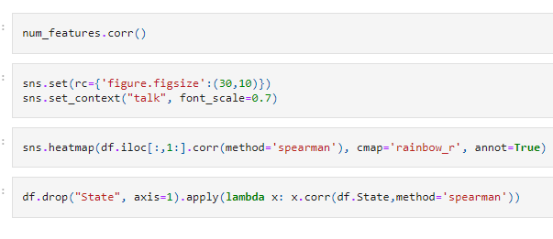

Final output will be as follows:

# Multivariate Analysis

In multivariate analysis, more than 2 variables are analyzed. It is a tremendously hard task for the human brain to visualize a relationship among 4 variables in a graph. This type of analysis is mostly used for studying more complex sets of data.

## Types

* Cluster analysis
* Factor Analysis
* Multiple Regression Analysis
* Principal Component Analysis

Many different ways exist to perform multivariate analysis. But it depends upon the type of data being used.

### Cluster Analysis

Cluster analysis is useful for finding groups of related objects in a data set. It tries to classify the objects in such a way that the similarity between two objects from the same group is maximum and minimum otherwise. A well-known example of clustering is in marketing, where customers are grouped into segments based on their buying patterns, demographics, and preferences.

### Correspondence Analysis

Correspondence Analysis using the data from a contingency table shows relative relationships between and among two different groups of variables. A contingency table is a 2D table with rows and columns as groups of variables.

### Principal Component Analysis

Principal Components Analysis (**PCA**) is a linear method for transforming a large dimensional data set into a smaller, standardized dimensionality that is more easily studied and understood. Here we are converting our original variables into a new set of variables called principal components that represent the most important dimensions in a dataset.

Some outputs are the following:

sns.boxplot(data=df,x='District',y='Party',hue='State')

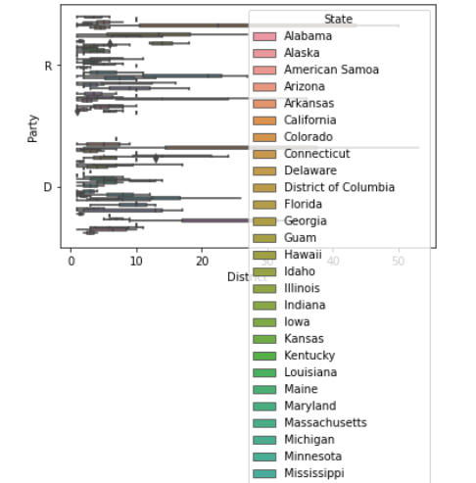

## Single Index:

Categorical value is compared with all continuous values with pivot tables. The following syntax will be followed:

# Single Index -

table = pd.pivot_table(data=df,index=['State'])

table

## Multiple Index

Multiple values are compared with all continuous values with pivot tables. The following syntax will be followed:

# Multiple  values concerning all continuous values in the dataset

table = pd.pivot_table(df,index=['Room','District'])

table

## Aggregates

Aggregates on specific features will be explored in the upcoming exercise. It involves the following code snippet:

# Aggregate on specific features with values parameter

table = pd.pivot_table(df,index=['Room','State'],dropna=False)

table

table = df.pivot_table(index=['Room','State'],

               columns='Assignment',

               aggfunc='size',

               fill_value=0,)

table

# Exercise 2.03: Multivariate analysis

In this exercise, you will practice the concepts related to the relationships between more than two variables. Load the dataset, import the visualization libraries and perform the analysis between more than two variables:

First, perform all the steps for loading data and for exploring the data covered in Exercises 2.01 and 2.02. Then perform the following steps to work on the multivariate analysis of the data.

1. Display the list of numerical features as shown below:

1. Plot box plots as follows:

Output will look like this figure:

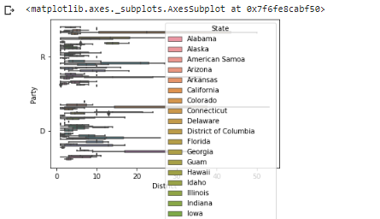

1. Compare the categorical variable with all continuous variables with pivo tables as shown below:

Output will be similar to this output:

1. Then explore the multiple values with respect to all continuous values in dataset as shown below:

Your output will look like this figure:

1. Then work on the aggregates on specific features with values parameters as shown below:

Final pivot table with aggfunc = ‘var’ will have the following output:

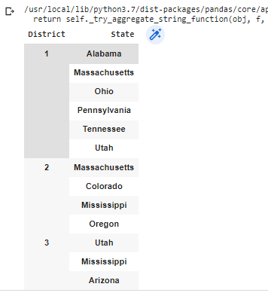

# Automated EDA Tooling

EDA describes the processes of detecting outliers, and missing values, converting categorical variables, and determining the skewness of the dataset. It can be tedious at times to comprehend your data and use it to build models, but with some helpful tools, you can quickly gain an understanding of your database and build better models.

In the upcoming exercise, we will be using “**sweetviz**” for the same purpose.

#Installing the library

!pip install dataprep

#Importing

from dataprep.eda import create_report

#Creating report

create_report(df)

!pip install skimpy

from skimpy import skim

skim(df)

#Installing the library

!pip install sweetviz

#Importing the library

import sweetviz as sv

report = sv.analyze(df)

report.show_html()

# Spliting data set into training and testing set

training_data = df.sample(frac=0.8, random_state=25)

testing_data = df.drop(training_data.index)

#Applying compare function

report2 = sv.compare([training_data,"TRAINING SET"], [testing_data, "TESTING SET"])

report2.show_html()

Finally, you will get the following output:



# Exercise 2.04: Automated EDA Tooling

In this exercise, you will practice the concepts related to some tools for EDA. Follow the same steps you learned before. Data Preprocessing is necessary. Load the dataset, import the visualization libraries, and perform the task.

Perform the following steps to practice the Automated EDA tooling techniques.

1. Open the collab notebook and import necessary libraries.
2. Load the dataset and perform other steps mentioned above.

Following output will be produced:

1. To start with it, install “dataprep” library as shown below:



1. Create report as shown below:

Report will look like this figure:

1. Install skimpy as shown below:

It will produce the following output:

1. Install sweetviz and show html as shown below:

# Activity 2.01: Loading the “City Land Mass - Miami” Dataset and performing Univariate and Bivariate Analysis on it.

In this activity, you will be checking the working on another dataset. This dataset contains the records of Landmass from Miami. You have to perform Univariate and bivariate analyses on the data to test the skill. Kindly apply the above-mentioned points covered in the exercises to implement them.

The steps are as follows:

1. Open the collab notebook and load the dataset mentioned above. It is shown here:



1. Import the required libraries. Visualization libraries will be imported for visuals.
2. Work on the Data Preprocessing to clean the dataset if required.
3. You need to perform the univariate analysis of Continuous variables.
4. Store columns with specific data types as shown below:

1. Plot the histograms to perform a univariate analysis.
2. Perform Bivariate Analysis of Categorical variables vs Continuous Variables.
3. Get a global view of all continuous variables with respect to one categorical variable.
4. Perform the **“groupby()**” operation to split the data into separate columns to perform computations for better analysis



**Note**: Firstly try to perform it yourself. Then verify it from the solution provided.

**In order to check the solution, you can access it from here:**

<https://github.com/fenago/datawrangling/blob/main/Chapter%202/Activity_2.01_Land_Mass_Miami.ipynb>

# Conclusion

In this chapter, we learned how to perform rigorous analysis on the dataset. Practicing EDA, we have seen Univariate, bivariate, and multivariate analyses of the data. Moreover, we have also learned about automated EDA tooling. Extensive methods were covered in this chapter to analyze the data.

It was observed that different types of relationships exist between the different variables. Moreover, different operations need to be performed between them depending upon their types. Similarly, the graphs were also dependent upon the type of data. It can be a numerical or a categorical variable, but it must be analyzed before starting the process. Data cleaning and Data preprocessing should also be done before starting the procedure.

In the next chapter, we will cover the “**Feature Engineering**” techniques, including feature selection, Feature Importance, Feature Reengineering, and binning.